# INTRODUCTION

* 1. Overview

A brief description about your project

* 1. Purpose

The use of this project. What can be achieved using this.

1. **Problem Definition & Design Thinking**
   1. Empathy Map

Paste the empathy map screenshot

* 1. Ideation & Brainstorming Map

Paste the Ideation & brainstorming map screenshot

# RESULT

Final findings (Output) of the project along with screenshots.

# ADVANTAGES & DISADVANTAGES

List of advantages and disadvantages of the proposed solution

# APPLICATIONS

The areas where this solution can be applied

# CONCLUSION

Conclusion summarizing the entire work and findings.

# FUTURE SCOPE

Enhancements that can be made in the future.

# APPENDIX

A. Source Code

Attach the code for the solution built.

### A Comprehensive Analysis of Financial Performance: Insights from A Leading Banks

1 INTRODUCTION

* 1. Overview

Project Description:

The banking industry world-wide is being transformed. The global forces for change include technological innovation; the deregulation of financial services at the national level and opening-up to international competition; and - equally important - changes in corporate behavior, such as growing disintermediation and increased emphasis on shareholder value. In addition, recent banking crises in Asia and Latin America have accentuated these pressures. The banking industries in central Europe and Latin America have also been transformed as a result of privatizations of state-owned banks that had dominated their banking systems in the past. In this project we are trying to analysis the bank related data and able to extract some insights from the data using Business Intelligence tools. To Extract the Insights from the data and put the data in the form of visualizations, Dashboards and Story we employed Tableau tool.

* 1. Purpose

The purpose of banking systems is to give security and confidence to the economy. A banking system operates in line with managing the flow of money between people and businesses.

A bank is a financial institution which is involved in borrowing and lending money. Banks take customer deposits in return for paying customers an annual interest payment. The bank then uses the majority of these deposits to lend to other customers for a variety of loans. The difference between the two interest rates is effectively the profit margin for banks. Banks play an important role in the economy for offering a service for people wishing to save. Banks also play an important role in offering finance to businesses who wish to invest and expand.  These loans and business investment are important for enabling economic growth.

1. Problem Definition & Design Thinking

Empathy Map

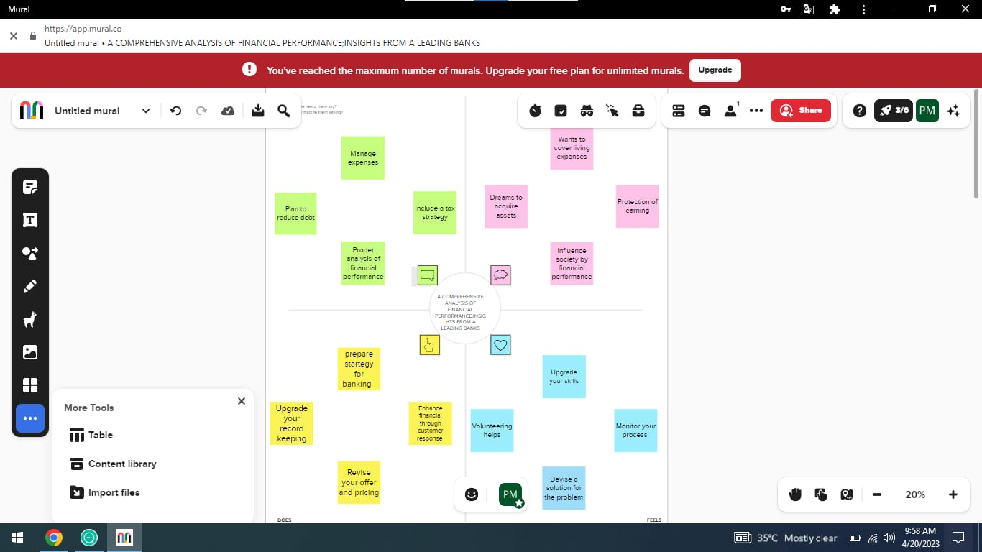

* 1. Ideation & Brainstorming Map

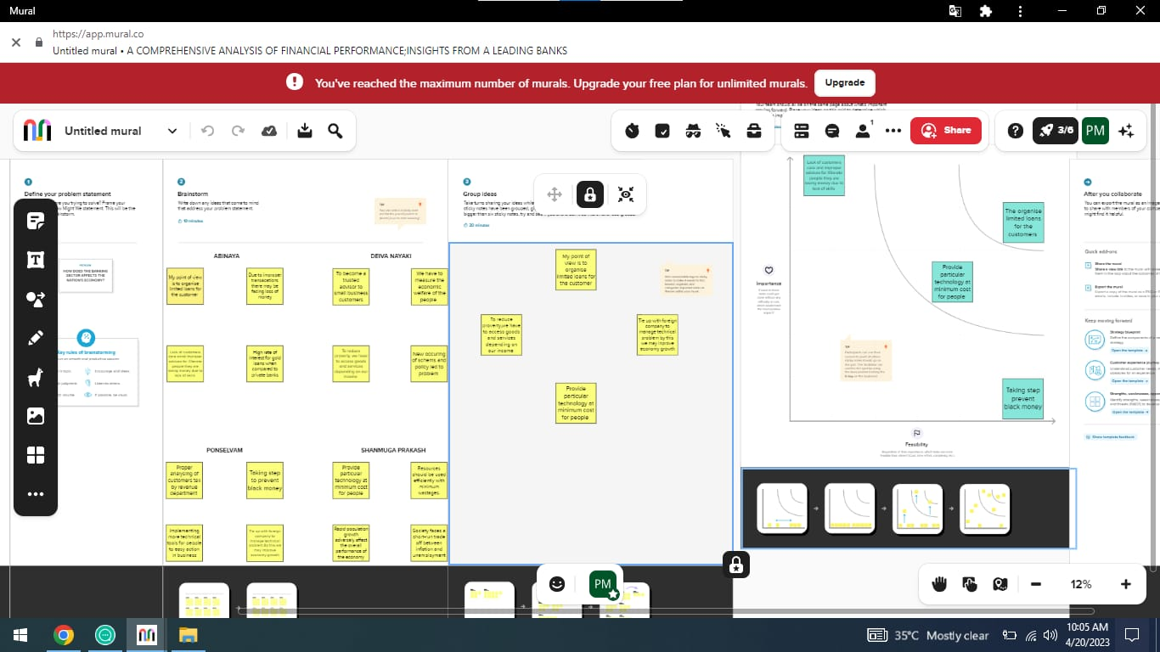

1. RESULT

Work sheets are created using Tableau with given dataset, the dashboards and stories are created using the worksheets. We have published our Dashboard and Story file in Tableau public. The published dashboard and story are given by

Dashboards:

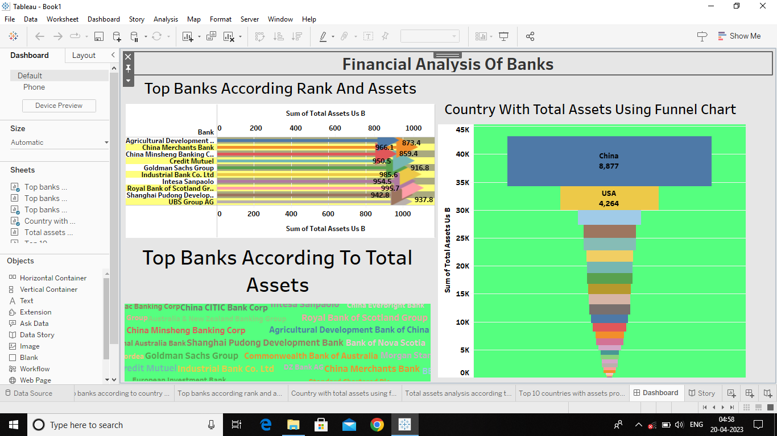

Story:

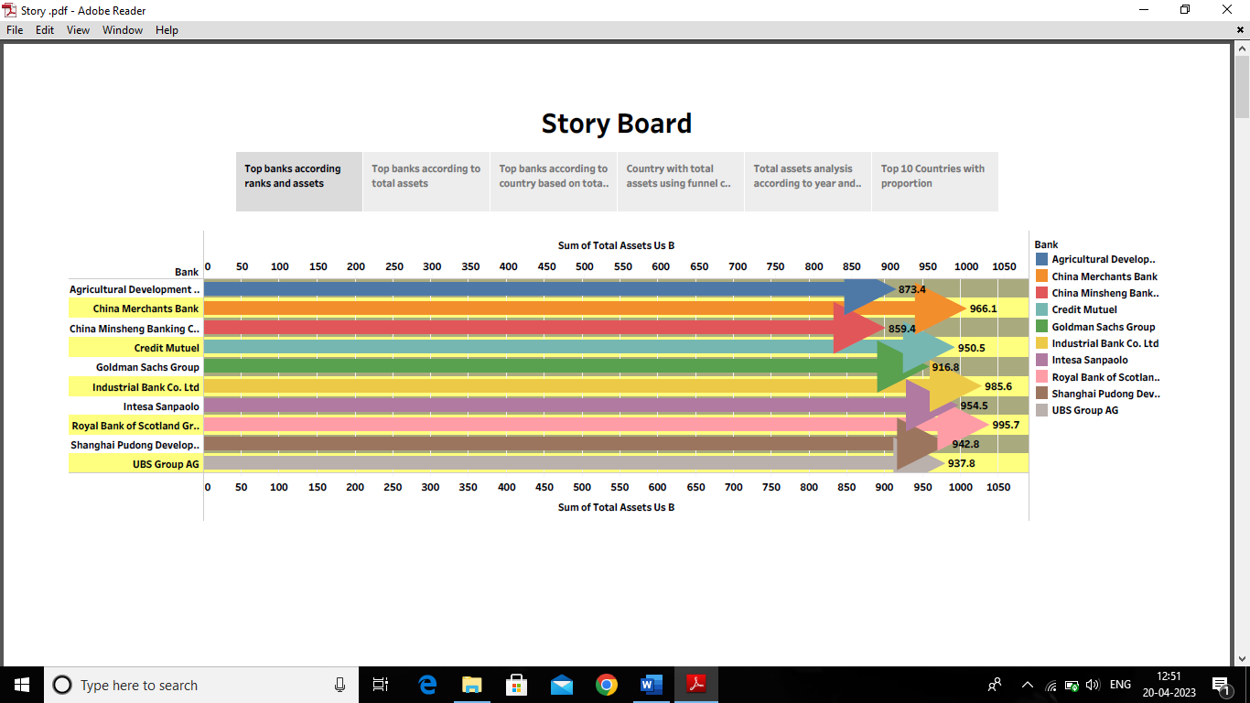

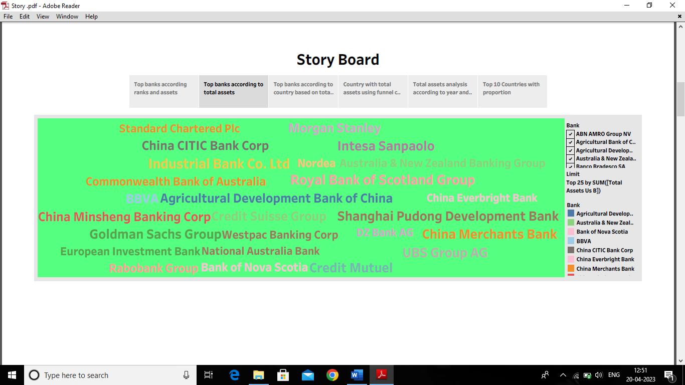

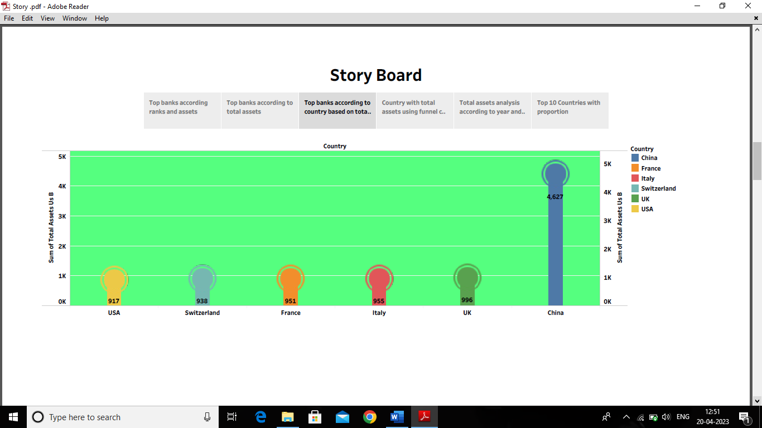

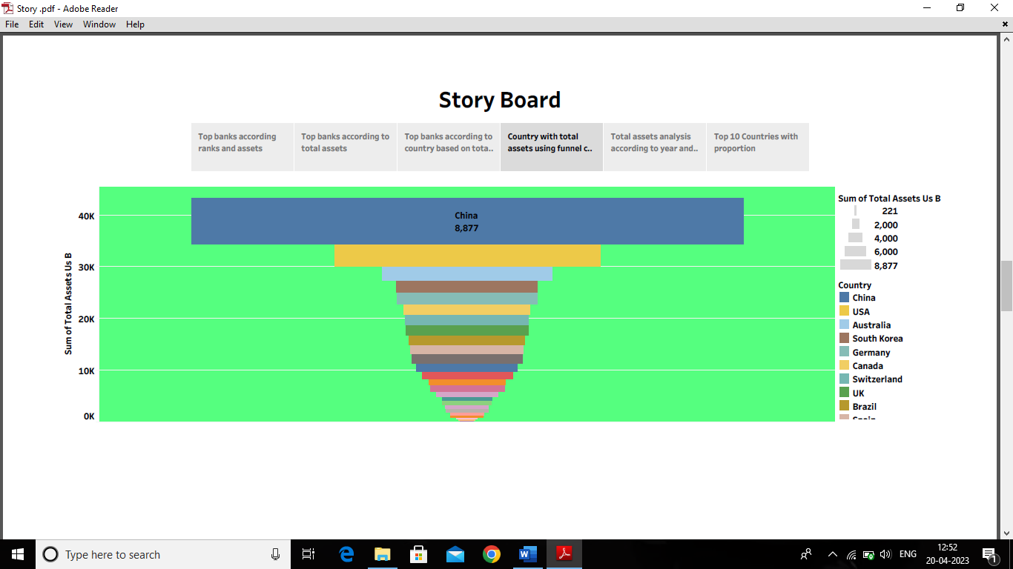

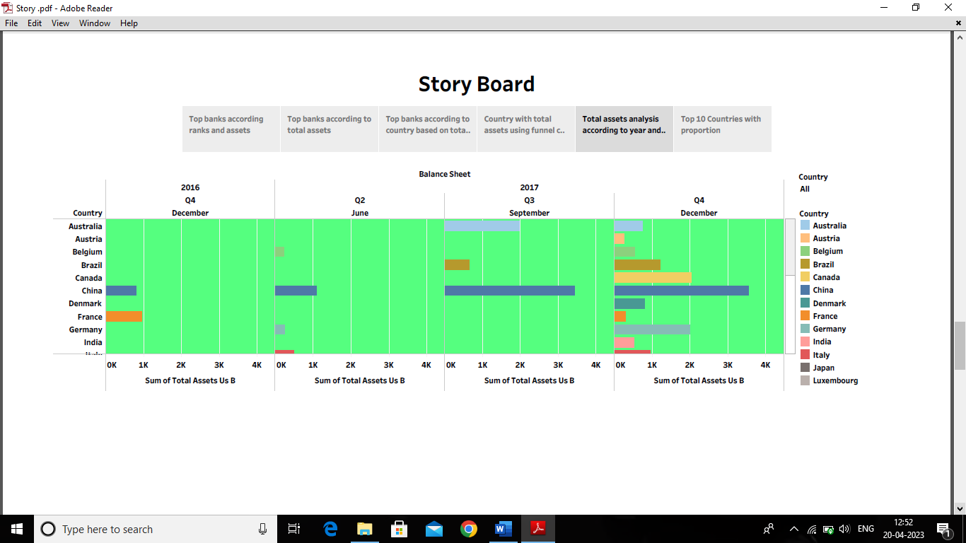

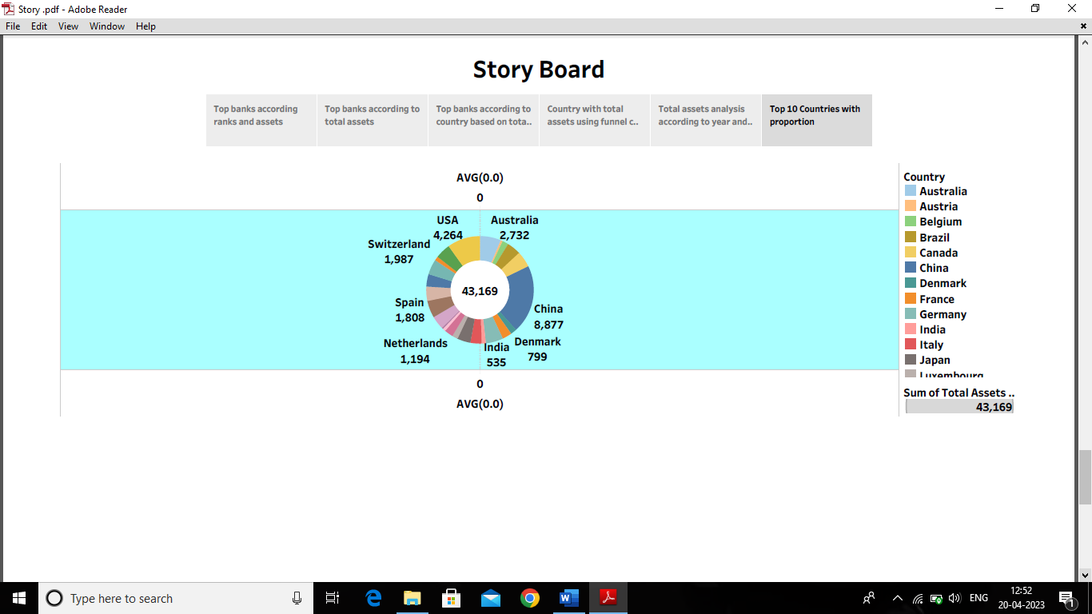

Web Integration: Dashboard & Story embed with UI with Flask

Dashboard:

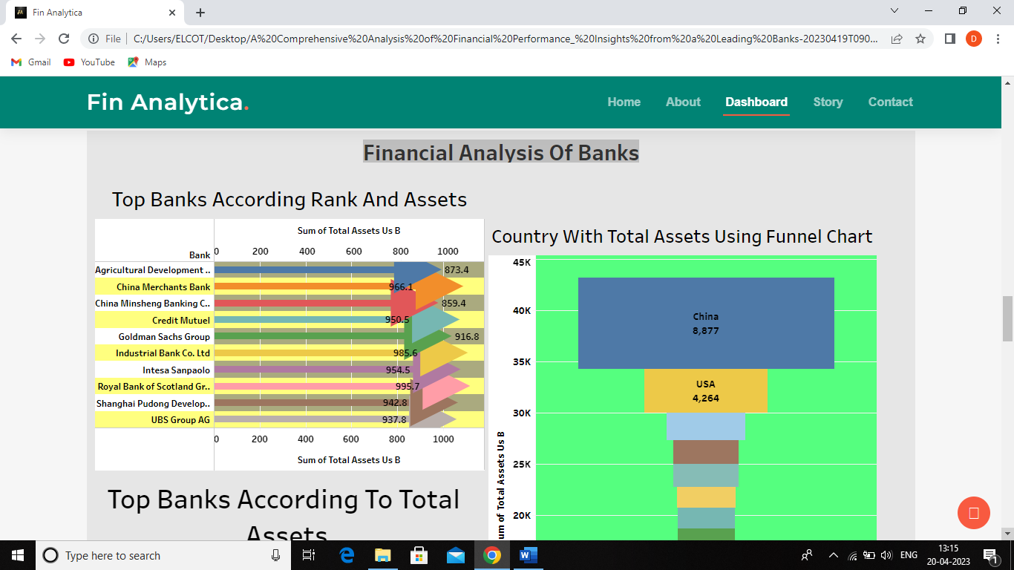

Story:

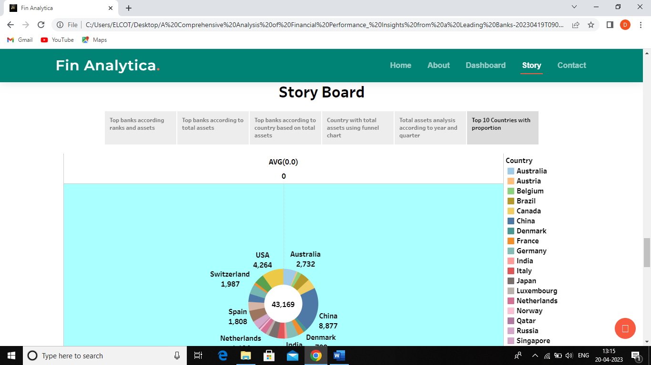

1. ADVANTAGES & DISADVANTAGES

By this proposed solution we can overview a detailed data on performance of financial analysis. This project gives the clear idea on Unique data visualization or graphs on a certain topic, the list of charts is

* Top banks according rank and assets
* Top banks according to total assets
* Top banks according to country based on total assets
* Top 10 Countries with assets proportion
* Country with total assets using funnel chart
* Total assets analysis according to year and quarter

Advantages:

* Every people can get the precise information on performing financial analysis very easily and comprehensible.
* By our project we can easily sort each and every data individually according to their countries, banks etc.
* A complete information about a bank can be seen on the basis of countries banks like if it is a total assets or ranks.
* The findings would be representative of the bank (since analyses are based on the performing of the banks).
* No need for sampling! (The entire banks are in our dataset).

Disadvantages:

* To collect all of the information for a bank it would likely take a great deal of time, which means more effort and money.
* We cannot get accurate data because some individuals may be missed on counting due to their contactless residencies.
* It may also pave way for discrimination and used to separate in the sense of majorities and minorities.

1. APPLICATIONS

Numerous applications exist for the financial performance of banking analysis. Banks assess their economic performance and health using financial performance analysis. To evaluate the bank's financial performance, financial ratios are used.

Financial statement analysis can be used to evaluate the company's profitability and any changes to its profits. Financial performance analysis is also used to contrast similar businesses within the same sector or to contrast whole markets or industries. It is analyses, among other standards, to assess the health and reputation of businesses.

1. CONCLUSIONS

Financial performance measures how effectively a bank can use its resources to generate income and meet its financial goals. It is a multifaceted idea that incorporates organizational effectiveness, human resource performance, financial and market performance, and performance focused on the needs of the customer. The health and stability of a bank can be determined by examining its financial accounts, which can also help to spot any possible dangers. Customer service and operations management can be used to improve financial performance. Overall, a bank's financial performance is a key factor in its success and calls for constant review and development.

1. FUTURE SCOPE

Future financial success in managing a bank is a challenging subject with many variables to take into account. The banking industry is changing, according to McKinsey, with key metrics at a historical low and unclear profit growth in the future. The difficulties, chances, and fresh prospects for the banking sector's future are highlighted in Deloitte's Bank of 2030 report. Customer service and operations management are two ways to improve financial performance, which can result in happier customers, more revenue, more sales, and a larger market share for the bank.

1. APPENDIX

* [Tableau public link for Deiva Nayaki. S](https://public.tableau.com/app/profile/deiva.nayaki.s)
* [Source Code](C://Users/ELCOT/Desktop/A%20Comprehensive%20Analysis%20of%20Financial%20Performance_%20Insights%20from%20a%20Leading%20Banks-20230419T090319Z-001/A%20Comprehensive%20Analysis%20of%20Financial%20Performance_%20Insights%20from%20a%20Leading%20Banks/index.html)